**Phase 1 – GanttProject**

**Singleton:**

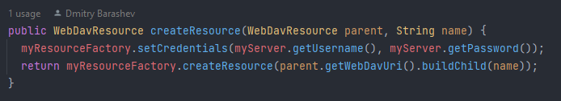

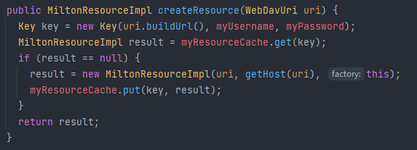

Ensures the creation of only one Milton Resource for each user (given its username and password).